Sentence Counter Technical Design
Name: Ean Eichelbaum
Date: October 22, 2026
Course: COP 2373
Program: sentence_counter.py

Program description
This Python program accepts a paragraph, displays each individual sentence on a separate numbered line, and displays the total number of sentences. It recognizes sentences beginning with capital letters or numbers and preserves their ending punctuation. All input, processing, and output logic is organized into four functions.

Input and output
Input: one paragraph entered on a single line. Press Enter to submit it. Output: a numbered list of sentences followed by Sentence count and the number found. Blank or whitespace-only input produces a count of zero.

Sentence detection
The program uses Python’s standard re module and re.findall with the following pattern:
[A-Z0-9].*?[.!?](?=\s+[A-Z0-9]|$)
Adapted from Section 7.4 of Supercharged Python by Brian Overland and John Bennett (2019), pages 224–226. Digits are added to both character classes, and the look-ahead accepts one or more whitespace characters before a capital letter or digit. Non-greedy matching stops at the earliest qualifying punctuation. re.DOTALL allows embedded newlines; re.MULTILINE allows a sentence ending at a line boundary.
Scope: a complete sentence begins with a capital letter or digit and ends with a period, question mark, or exclamation mark. An unfinished trailing fragment is not counted. The textbook heuristic preserves abbreviations followed by lowercase words and decimal points, but it does not fully interpret titles such as Dr. before a capitalized name or quoted dialogue.

How to run
Use Python 3. No third-party packages are needed. Run python sentence_counter.py from the folder containing the file.

Repository
https://github.com/Eichelbaum156/COP-2373-

Function design

get_paragraph
Read and trim the paragraph.
Parameters: None.
Variables: paragraph (str): keyboard input with surrounding whitespace removed.
Logical steps: Prompt the user to enter a paragraph. → Read the input and remove leading and trailing whitespace. → Return the paragraph.
Return value: str: the entered paragraph.

split_sentences
Find sentences using a regular expression.
Parameters: paragraph (str): the paragraph to analyze.
Variables: pattern (str): the regular expression; sentences (list of str): the matches.
Logical steps: Define a pattern that accepts a capital letter or number at the start and in the look-ahead. → Use re.findall to collect sentences in their original order. → Return the list of sentences.
Return value: list of str: detected sentences; an empty list when none are found.

display_sentences
Display individual sentences and their count.
Parameters: sentences (list of str): sentences to display.
Variables: number (int): position starting at 1; sentence (str): current sentence.
Logical steps: Print the output heading. → Loop through enumerate(sentences, start=1). → Print each number and sentence on its own line. → Print len(sentences) as the total.
Return value: None; results are printed to the console.

main
Coordinate the program.
Parameters: None.
Variables: paragraph (str): user input; sentences (list of str): detected sentences.
Logical steps: Call get_paragraph and store the input. → Pass the paragraph to split_sentences. → Pass the returned list to display_sentences.
Return value: None.

Testing and results
Seven automated comparisons checked the actual sentence lists against expected results. All seven passed. A separate interactive program run completed without errors and produced the four sentences shown below.
- Mixed punctuation: Hello world. How are you? Great! — 3 sentences.
- Number-led sentences: 2026 is here. 3 students passed! Did all 3 finish? — 3 sentences.
- Empty input — 0 sentences.
- Whitespace-only input — 0 sentences.
- No ending punctuation: One sentence — 0 complete sentences.
- Decimal: It costs 3.50 dollars. 2 people paid. — 2 sentences.
- Abbreviations: See the U.S.A. today. Average temp. is 66.5. — 2 sentences.

Screenshot of program execution
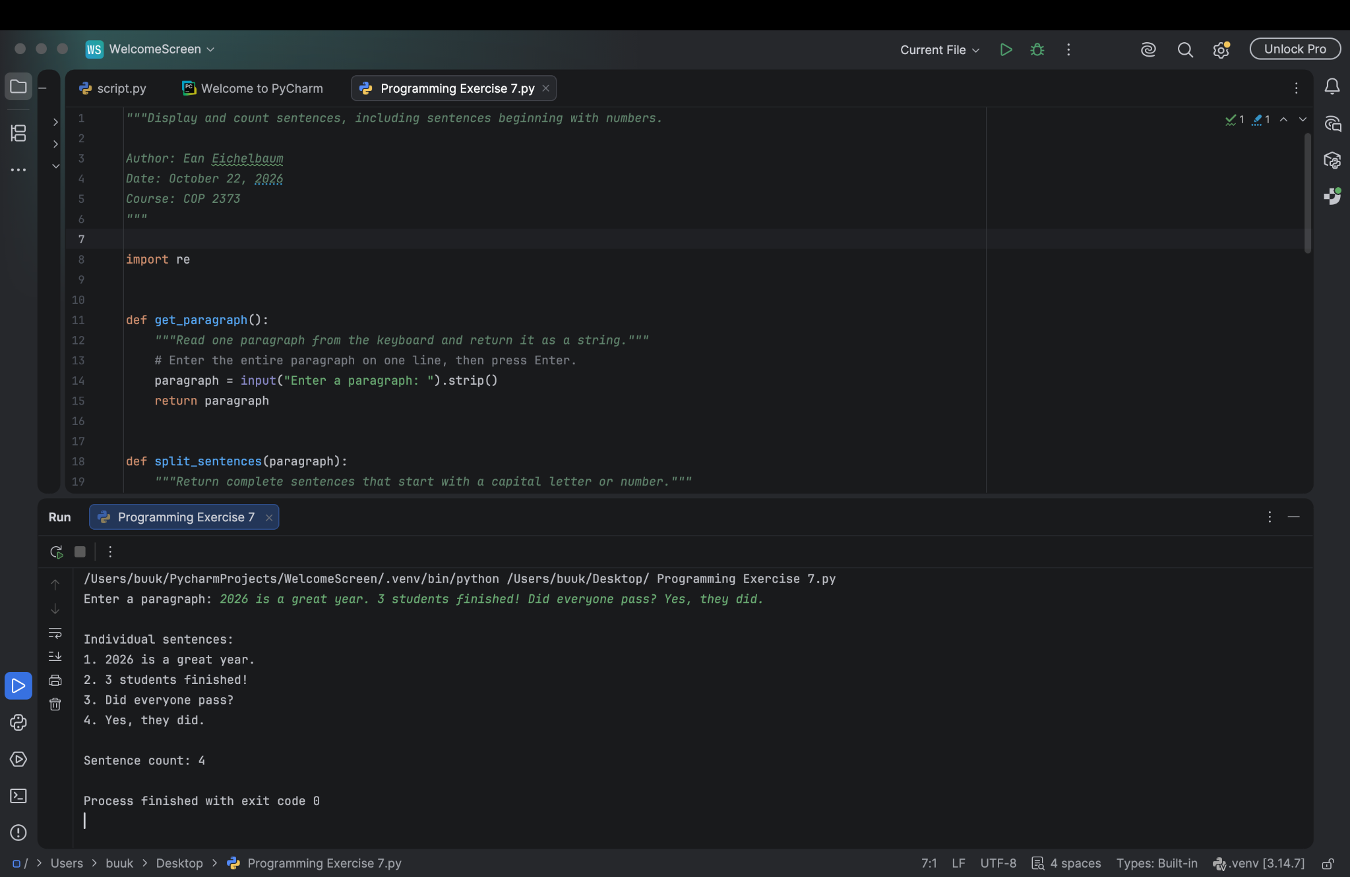
Figure 1. Program execution in PyCharm, saved locally as Programming Exercise 7.py. The number-led sentences are included, the total is 4, and exit code 0 confirms successful completion.

